Shestopalov Sergei
Position applied for: Motorman 1st class  Date of birth: 04.06.1978 (age: 39)  Citizenship: Ukraine  Residence permit in Ukraine: Yes  Country of residence: Ukraine  City of residence: Bolhrad  Permanent address: inzovskaia-55  Contact Tel. No: +38 (048) 464-23-63 / +38 (098) 587-73-00  E-Mail: serega.shestopalov@mail.ru  Skype: shestopalov80  U.S. visa: No  E.U. visa: No  Ukrainian biometric international passport: Not specified  Date available from: 15.11.2017  English knowledge: Poor  Minimum salary: 1800 $ per month | 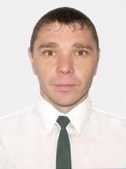

Experience:
Position | From / To | Vessel name | Vessel type | DWT | ME | BHP | Flag | Shipowner | Crewing
Oiler | 28.07.2013-11.03.2014 | MINERAL FAITH | Bulk Carrier | 175580 | 16860 | 91970 | HONG KONG | BOSIMAR HONG-KONG LIMITED | ANGLO-EASTERN

Documents and further information:
WELDER

