Apostol Andriy Vasylevich
Position applied for: 3rd Officer  Date of birth: 26.05.1983 (age: 34)  Citizenship: Ukraine  Residence permit in Ukraine: No  Country of residence: Ukraine  City of residence: Odessa  Contact Tel. No: +38 (048) 245-07-97 / +38 (067) 483-37-58  E-Mail: av-apostol@mail.ru  U.S. visa: No  E.U. visa: No  Ukrainian biometric international passport: Not specified  Date available from: 15.02.2013  English knowledge: Moderate  Minimum salary: 2500 $ per month | 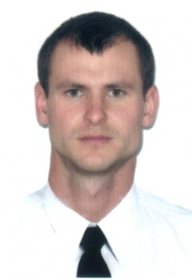

Experience:
Position | From / To | Vessel name | Vessel type | DWT | ME | BHP | Flag | Shipowner | Crewing
3rd Officer | 05.07.2014-21.02.2014 | Kamil | Bulk Carrier | 11816 |  | - | Panama | N.S.C corparation | Business Consalt
3rd Officer | 09.06.2012-26.10.2012 | Pacific Future | Universal Ship | 25500 |  | - | Belize | Machico Carrier inc. | Unimars
Able Seaman | 21.03.2010-14.09.2010 | Pacific Future | Universal Ship | 25500 |  | - | Belize | Machico Carrier inc. | Unimars
Able Seaman | 29.04.2009-15.11.2009 | Everest | Universal Ship | 17493 |  | - | Belize | Machico Carrier inc. | Unimars
Able Seaman | 07.07.2008-11.02.2009 | African Lark | Universal Ship | 17493 |  | - | Belize | Machico Carrier inc. | Unimars
Able Seaman | 19.09.2007-21.04.2008 | Safmarine Cavalla | Universal Ship | 17493 |  | - | Belize | Machico Carrier inc. | Unimars

