Novytskyi Ivan Mykolayovic
Position applied for: Able Seaman  Date of birth: 14.07.1986 (age: 31)  Citizenship: Ukraine  Residence permit in Ukraine: No  Country of residence: Ukraine  City of residence: Kherson  Permanent address: 27, 1-Suburb, Kherson, 73002, Ukraine  Contact Tel. No: +38 (055) 234-33-74 / +38 (066) 764-72-64  E-Mail: Lee14071986@mail.ru  U.S. visa: No  E.U. visa: No  Ukrainian biometric international passport: Not specified  Date available from: 26.01.2013  English knowledge: Moderate  Minimum salary: 800 $ per month | 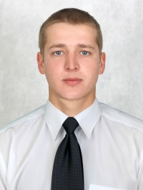

Experience:
Position | From / To | Vessel name | Vessel type | DWT | ME | BHP | Flag | Shipowner | Crewing
Ordinary Seaman | 10.04.2013-26.12.2013 | Tavr | Research vessel | 2371 |  | - | Ukr | Lartis | MARIN-SERVIS LTD
Ordinary Seaman | 22.11.2012-10.03.2013 | SKYLARK | Dry Cargo | 2466 |  | - | Ukr | CAPITAL SHIPPING CO | &mdash;
Deck Cadet | 10.04.2012-11.06.2012 | Diorit |  | 762 |  | - | ukr | GRGP | &mdash;

