Пакалов Валерий Алексеевич
Position applied for: Ordinary Seaman  Date of birth: 06.03.1966 (age: 51)  Citizenship: Ukraine  Residence permit in Ukraine: No  Country of residence: Ukraine  City of residence: Mariupol  Permanent address: б. Шевченко 258-76  Contact Tel. No: +38 (097) 227-80-87  E-Mail: annushka_06@mail.ru  U.S. visa: No  E.U. visa: No  Ukrainian biometric international passport: Not specified  Date available from: 12.08.2009  English knowledge: Poor  Minimum salary: 800-1000 $ per month | 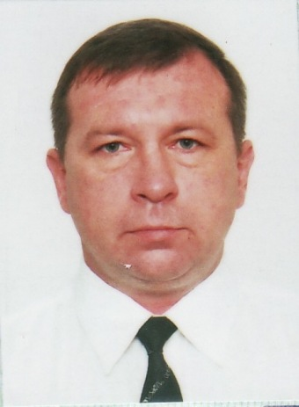

Experience:
Position | From / To | Vessel name | Vessel type | DWT | ME | BHP | Flag | Shipowner | Crewing
Able Seaman | 19.08.2008-10.05.2009 | LARIX |  | 1820 |  | - | Batumi |  | AVREK

