Furmanets Yevgen Borisovich
Position applied for: Electrician  Date of birth: 14.06.1989 (age: 28)  Citizenship: Ukraine  Residence permit in Ukraine: Yes  Country of residence: Ukraine  City of residence: Kherson  Contact Tel. No: +38 (066) 510-13-00 / +38 (063) 630-61-01  E-Mail: jek_son@ukr.net  Skype: jek_son@ukr.net  U.S. visa: No  E.U. visa: No  Ukrainian biometric international passport: Not specified  Date available from: 01.03.2018  English knowledge: Moderate  Minimum salary: 2000 $ per month | 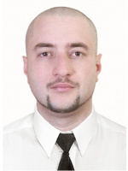

Experience:
Position | From / To | Vessel name | Vessel type | DWT | ME | BHP | Flag | Shipowner | Crewing
Electrician | 18.03.2017-18.09.2017 | m/v Svyatogor | Dry Cargo | 5200 |  | - | Tanzania |  | Eurobalk Agency Odessa

Documents and further information:
.

