Kuzminsky Viktor
Position applied for: Master  Date of birth: 10.08.1946 (age: 71)  Citizenship: Ukraine  Residence permit in Ukraine: No  Country of residence: Ukraine  City of residence: &mdash;  Contact Tel. No: +38 (048) 415-86-66 / +38 (095) 468-42-85  E-Mail: kuzlid2@mail.ru  U.S. visa: No  E.U. visa: No  Ukrainian biometric international passport: Not specified  Date available from: 30.12.2013  English knowledge: Good  Minimum salary: 6000 $ per month | 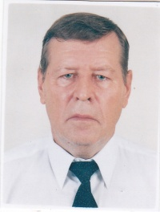

Experience:
Position | From / To | Vessel name | Vessel type | DWT | ME | BHP | Flag | Shipowner | Crewing
Master | 25.04.2012-17.09.2012 | AMBRA | General Cargo | 18500 | MAN | 8000 | Malta | Vima Management s.r.l., Italy | Orion Shipping, Izmail
Master | 19.05.2011-07.10.2011 | AMBRA | General Cargo | 18500 | MAN | 8000 | Malta | Vima Management s.r.l., Italy | Orion Shipping, Izmail
Master | 23.06.2010-12.11.2010 | AMBRA | General Cargo | 18500 | MAN | 8000 | Malta | Vima Management, Italy | Orion Shipping, Izmail
Master | 02.07.2009-26.11.2009 | ABRAHAM | General Cargo | 18500 | MAN | 8000 | Malta | Seferoglu Shipping, Turkey | Orion Shipping, Izmail

Documents and further information:
All seamans documents are valided until 31 Dec 2016.USA visa up to June 2014.Panama Endorsements until Dec 2016.

