Иващенко Владимир Николаевич
Position applied for: Master  Date of birth: 15.08.1972 (age: 45)  Citizenship: Ukraine  Residence permit in Ukraine: No  Country of residence: Ukraine  City of residence: Kherson  Contact Tel. No: +38 (096) 458-44-92  E-Mail: spidermail@mail.ru  U.S. visa: No  E.U. visa: No  Ukrainian biometric international passport: Not specified  Date available from: 01.08.2009  English knowledge: Excellent  Minimum salary: 9500 $ per month | 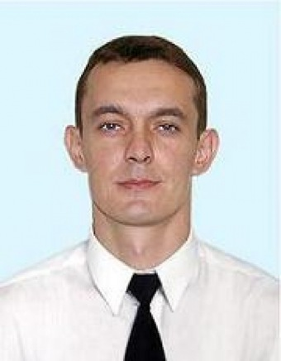

Experience:
Position | From / To | Vessel name | Vessel type | DWT | ME | BHP | Flag | Shipowner | Crewing
Master | 24.01.2007-22.06.2007 | MSC GRACE | Container Ship | 17298 |  | - | PAN | MSC | MAU
Master | 18.02.2006-26.08.2006 | SIMA TOUBA | Container Ship | 19244 |  | - | CYP | SIMATECH | EUGENIA
Master | 12.07.2005-13.12.2005 | EUROCARRIER | Bulk Carrier | 27450 |  | - | PAN | MEDITERRANEAN MNGMNT | TRANS LINK
Master | 10.09.2007-21.05.0208 | MSC ASLI | Container Ship | 32400 |  | - | PAN | MSC | MSC

