ÐÐ»ÐµÐ¹Ð½Ð¸Ðº ÐÐ¸ÐºÐ¾Ð»Ð°Ð¹ ÐÐ¸ÐºÑÐ¾ÑÐ¾Ð²Ð¸Ñ
Position applied for: Cook  Date of birth: 22.09.1988 (age: 29)  Citizenship: Ukraine  Residence permit in Ukraine: Yes  Country of residence: Ukraine  City of residence: Reni  Contact Tel. No: +38 (097) 173-31-22  E-Mail: mukola007@bigmir.net  Skype: kalyn  U.S. visa: No  E.U. visa: No  Ukrainian biometric international passport: Not specified  Date available from: 25.01.2018  English knowledge: Good  Minimum salary: 800-1400 $ per month | 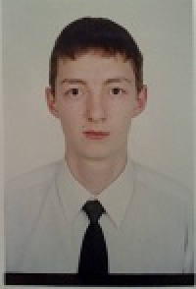

Experience:
Position | From / To | Vessel name | Vessel type | DWT | ME | BHP | Flag | Shipowner | Crewing
Cook | 08.07.2008-14.07.2009 | Moscow-1 | Tug Boat |  |  | - |  |  | &mdash;
Waiter | 23.04.2007-29.09.2007 | Dniper Star | Passenger Ship |  |  | - |  | Chervona Ruta | &mdash;

