Knyazhev Oleksandr Oleksandrovich
Position applied for: Deck Cadet  Date of birth: 05.05.1995 (age: 22)  Citizenship: Ukraine  Residence permit in Ukraine: No  Country of residence: Ukraine  City of residence: Izmail  Permanent address: 24-B Lenina avenue  Contact Tel. No: +38 (048) 415-57-21 / +38 (063) 577-76-20  E-Mail: Alex_A1713@mail.ru  U.S. visa: No  E.U. visa: No  Ukrainian biometric international passport: Not specified  Date available from: 25.03.2014  English knowledge: Good  Minimum salary: 350 $ per month | 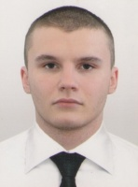

Experience:
Position | From / To | Vessel name | Vessel type | DWT | ME | BHP | Flag | Shipowner | Crewing
Deck Cadet | 29.05.2013-07.08.2013 | Buyalik | Tug Boat | 3600 |  | - | UA |  | UA Danube Shipping Co

Documents and further information:
Personal safety
Prof. in survival craft

