Karpov Denys Nikolaevich
Position applied for: 2nd Officer  Date of birth: 17.05.1988 (age: 29)  Citizenship: Ukraine  Residence permit in Ukraine: No  Country of residence: Ukraine  City of residence: Sevastopol  Permanent address: Borisa Mikhailova 21 fl 12  Contact Tel. No: +7 (869) 241-12-57 / +7 (978) 749-89-05  E-Mail: sventol@mail.ru  U.S. visa: No  E.U. visa: No  Ukrainian biometric international passport: Not specified  Date available from: 25.12.2013  English knowledge: Excellent  Minimum salary: 3500 $ per month | 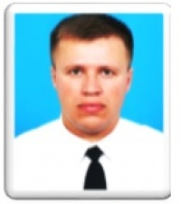

Experience:
Position | From / To | Vessel name | Vessel type | DWT | ME | BHP | Flag | Shipowner | Crewing
2nd Officer | 11.08.2013-19.11.2013 | ANT-2 | Ro-Ro | 4035 |  | - | Moldova | Shiva Assets S.A. | &mdash;

