Hetun Andriy Volodimirovich
Position applied for: Chief Engineer  Date of birth: 30.05.1976 (age: 41)  Citizenship: Ukraine  Residence permit in Ukraine: No  Country of residence: Ukraine  City of residence: Sevastopol  Contact Tel. No: +38 (066) 330-33-34  E-Mail: japanhetun1@gmail.com  U.S. visa: No  E.U. visa: No  Ukrainian biometric international passport: Not specified  Date available from: 05.10.2015  English knowledge: Good  Minimum salary: 8000 $ per month | 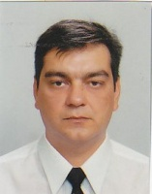

Experience:
Position | From / To | Vessel name | Vessel type | DWT | ME | BHP | Flag | Shipowner | Crewing
Chief Engineer | 23.03.2013-20.07.2013 | Govern | Container Ship | 45000 | Sulzer 6 RLB 90 | 24000 | Marshall Islands | Prime Stone Marine | Lemissoler

