Baklan Oleksii
Position applied for: Ordinary Seaman  Date of birth: 10.01.1995 (age: 22)  Citizenship: Ukraine  Residence permit in Ukraine: No  Country of residence: Ukraine  City of residence: Mykolayiv  Permanent address: 59-A Kosmonavtov str., fl.46, Nikolaev  Contact Tel. No: +38 (051) 223-44-00 / +38 (093) 380-03-42  E-Mail: alex_boka@mail.ru  U.S. visa: No  E.U. visa: No  Ukrainian biometric international passport: Not specified  Date available from: 15.02.2014  English knowledge: Good  Minimum salary: 700 $ per month | 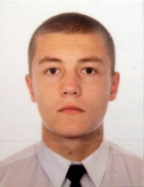

Experience:
Position | From / To | Vessel name | Vessel type | DWT | ME | BHP | Flag | Shipowner | Crewing
Deck Cadet | 18.06.2013-15.09.2013 | Nerey | General Cargo | 2151 | 8VDS36/24A-1 | 880 | Moldova | Grotmar LLC. USA | Niesco

