Письмак Юрий Петрович
Position applied for: 2nd Officer  Date of birth: 28.06.1965 (age: 52)  Residence permit in Ukraine: No  Country of residence: Ukraine  City of residence: Kherson  Permanent address: ул. Перекопская 21 кв 112  Contact Tel. No: +38 (050) 824-65-61  E-Mail: malysh31@gmail.com  U.S. visa: No  E.U. visa: No  Ukrainian biometric international passport: Not specified  Date available from: 20.08.2009  English knowledge: Good  Minimum salary: 5000 $ per month | 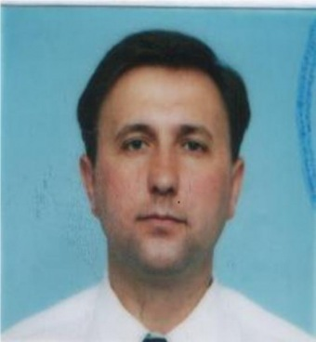

Experience:
Position | From / To | Vessel name | Vessel type | DWT | ME | BHP | Flag | Shipowner | Crewing
3rd Officer | 18.08.2006-08.10.2006 | Kenwood Park | Chemical Tanker | 40000 | B&W | 13100 | Liberia | Zodiac/UK | Zodiac
3rd Officer | 01.11.2005-08.05.2006 | Nordtrave | Bulk Carrier | 75000 | B&W | 16000 | Cyprus | Reederei Nord/Germany | Lais
3rd Officer | 03.07.2004-16.04.2005 | Saetta | Tanker Crude | 60000 | B&W | 13000 | Malta | Cardiff/Greece | Seaway
3rd Officer | 24.10.2003-02.04.2004 | Cordoba Carrier | Refrigerator | 6000 | Mitsubishi | 7200 | Bahamas | Norbulk/UK | Hanza
3rd Officer | 14.05.2002-14.03.2003 | Nikos N | Bulk Carrier | 40000 | Sulzer | 9450 | Cyprus | Nomikos/Greece | Marinproservice

Documents and further information:
Виза США в производстве. При необходимости могу выслать все отсканированные документы.

