Buylov Sergiy
Position applied for: Chief Engineer  Date of birth: 27.03.1963 (age: 54)  Citizenship: Ukraine  Residence permit in Ukraine: Yes  Country of residence: Ukraine  City of residence: Odessa  Permanent address: 59l Wiliamsa str.apt 69  Contact Tel. No: +38 (097) 210-04-65  E-Mail: valeria1963@bk.ru  Skype: cartagena114  U.S. visa: No  E.U. visa: No  Ukrainian biometric international passport: Not specified  Date available from: 12.12.2016  English knowledge: Good  Minimum salary: 13000 $ per month | 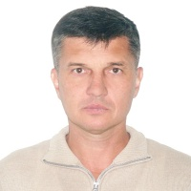

Experience:
Position | From / To | Vessel name | Vessel type | DWT | ME | BHP | Flag | Shipowner | Crewing
Chief Engineer | 07.07.2015-10.12.2016 | Mandume | Oil Chemical Tanker | 7400 | Wartsila | 5000 | Marshail Island | Trafigura | BSM

