Mischenko Oleksandr
Position applied for: Master  Date of birth: 18.08.1971 (age: 46)  Citizenship: Ukraine  Residence permit in Ukraine: Yes  Country of residence: Ukraine  City of residence: Dnipro  Contact Tel. No: +38 (095) 612-47-61  E-Mail: mischenko@ua.fm  Skype: mivaal  U.S. visa: No  E.U. visa: No  Ukrainian biometric international passport: Not specified  Date available from: 27.04.2017  English knowledge: Good  Minimum salary: 6500 $ per month | 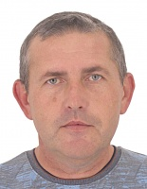

Experience:
Position | From / To | Vessel name | Vessel type | DWT | ME | BHP | Flag | Shipowner | Crewing
Master | 15.01.2016-28.08.2016 | Aman | Container Ship | 6000 |  | - | Bahrain | Tylos shipping | Almagest

