Syrbul Oleksiy Anatoliyovich
Position applied for: 2nd Officer  Date of birth: 03.10.1982 (age: 35)  Citizenship: Ukraine  Residence permit in Ukraine: No  Country of residence: Ukraine  City of residence: Odessa  Contact Tel. No: +38 (048) 254-24-17 / +38 (097) 626-80-57  E-Mail: marunia21@yandex.ru  U.S. visa: No  E.U. visa: No  Ukrainian biometric international passport: Not specified  Date available from: 20.08.2011  English knowledge: Moderate  Minimum salary: 2000 $ per month | 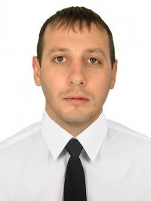

Experience:
Position | From / To | Vessel name | Vessel type | DWT | ME | BHP | Flag | Shipowner | Crewing
2nd Officer | 11.03.2011-22.07.2011 | LISANNE | Dry Cargo | 1865 | Sulzer | 1820 | Panama | W.S.M.S. | Asap
Able Seaman | 08.11.2008-13.03.2009 | SICHEM PALACE | Oil Product Tanker | 5451 | Mitsubishi | 3900 | Singapure | E.M.S | Totus
Ordinary Seaman | 10.04.2008-13.09.2008 | SICHEM PALACE | Oil Product Tanker | 5451 | Mitsubishi | 3900 | Singapure | E.M.S | Totus
Able Seaman | 23.05.2007-27.12.2007 | Ahora | Dry Cargo | 6835 | Sulzer | 4100 | Ned.Antillas | A.C.M | Aqvarius
Able Seaman | 16.09.2006-28.03.2007 | Ahora | Dry Cargo | 6835 | Sulzer | 4100 | Ned.Antillas | A.C.M | Aqvarius

