Ratushniuk Olexander Olexandrovich
Position applied for: Electrical Engineer  Date of birth: 02.08.1991 (age: 26)  Citizenship: Ukraine  Residence permit in Ukraine: No  Country of residence: Ukraine  City of residence: Ochakiv  Permanent address: Sverdlov str., 79  Contact Tel. No: +38 (051) 543-06-57 / +38 (095) 887-12-32  E-Mail: a.ratushnyuk@mail.ru  U.S. visa: No  E.U. visa: No  Ukrainian biometric international passport: Not specified  Date available from: 20.06.2014  English knowledge: Good  Minimum salary: 1300 $ per month | 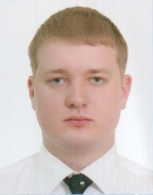

Experience:
Position | From / To | Vessel name | Vessel type | DWT | ME | BHP | Flag | Shipowner | Crewing
Electrician | 16.06.2013-16.12.2013 | NIBULON-2 | Tug Boat | 140 | Mitsubishi | 2560 | Ukraine | NIBULON Ltd. | &mdash;

