Оленберг Андрей Викторович
Position applied for: Welder  Date of birth: 27.09.1982 (age: 35)  Citizenship: Ukraine  Residence permit in Ukraine: No  Country of residence: Ukraine  City of residence: Odessa  Permanent address: vil.NOVOGRADOVKA reg.ODESSA str.SADOVAYA71/a  Contact Tel. No: +38 (067) 418-28-83  E-Mail: OLENBERG82@MAIL.RU  U.S. visa: No  E.U. visa: No  Ukrainian biometric international passport: Not specified  Date available from: 13.05.2009  English knowledge: Excellent  Minimum salary: 2000 $ per month | 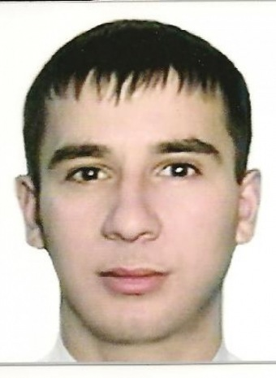

Experience:
Position | From / To | Vessel name | Vessel type | DWT | ME | BHP | Flag | Shipowner | Crewing
Welder | 08.12.2008-15.03.2009 |  | Tanker Product |  |  | - |  |  | &mdash;
Welder | 04.04.2008-03.10.2008 |  | Multi-Purpose Vessel |  |  | - |  |  | &mdash;
Welder | 08.08.2007-21.01.2008 |  | Bulk Carrier |  |  | - |  |  | &mdash;

Documents and further information:
SEAMANS INDENTIFICATION CARD-Date of issue 30jul.2007-Date of expiry30jul.2012 №AB365285 ;TRAVEL PASSPORT Date of issue-25APR.2005-Date of expiry-APR.2015 №EC164183;SHIPS WELDER FOURTH CLASS№00331/2007/08 Date of expiry-12.07.2012.;BASIC SAFETY TRAINING AND INSTRUCTION№/21662/07.Date of expiry 18.06.2012.TANKER FAMILIRIZATION№2/426/06.Date of expiry-18.06.2012.;PROFICIENCY IN SURVIVAL CRAFT AND RESCUE BOATS№2/1476/07.Date of expiry-18.06.2012. NEXT EXAMINATION Date-02 DEC.2009. USA VISA№95406173. Expiration Date03FEB.2013.

