Rehush Anton Vasilivich
Position applied for: Motorman 2nd class  Date of birth: 03.07.1988 (age: 29)  Citizenship: Ukraine  Residence permit in Ukraine: No  Country of residence: Ukraine  City of residence: Kherson  Contact Tel. No: +38 (050) 875-79-65 / +38 (055) 234-21-07  E-Mail: anton.regush@mail.ru  U.S. visa: No  E.U. visa: No  Ukrainian biometric international passport: Not specified  Date available from: 16.04.2013  English knowledge: Moderate  Minimum salary: 800 $ per month | 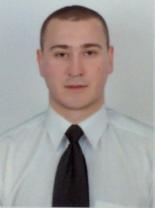

Experience:
Position | From / To | Vessel name | Vessel type | DWT | ME | BHP | Flag | Shipowner | Crewing
Motorman-Oiler | 11.11.2011-15.06.2012 | Batur | Dry Cargo | 3135 | NVD | 1318 | Cambodia | Marmara Shipping co. | ÐÐºÐºÐµÑÐ¼Ð°Ð½ Ð¨Ð¸Ð¿Ð½Ð³ ÐÐ¾Ð¼Ð¿Ð°Ð½Ð¸
Motorman-Oiler | 19.02.2008-24.07.2008 | Merton1 | Dry Cargo | 2592 | skoda | 1552 | Moldova | Sila shipping company | &mdash;

Documents and further information:
Dear Sirs, good morning!
I m experienced motorman with qualified motorman certificate of competence on hands.
Have tanker document on hand. I am ready now.
My CV form is attached herewith.
I study in Kherson Maritame Academy.
Kindly revert with any prospects of employment in your good company for Motorman.
Do not hesitate to contact me.
Thanking you in advance.

