Gramma Cergey Borisovich
Position applied for: 3rd Engineer  Date of birth: 04.08.1987 (age: 30)  Citizenship: Ukraine  Residence permit in Ukraine: No  Country of residence: Ukraine  City of residence: Izmail  Contact Tel. No: +38 (048) 414-72-84 / +38 (096) 847-39-85  E-Mail: gramma.ser@yandex.ua  U.S. visa: No  E.U. visa: No  Ukrainian biometric international passport: Not specified  Date available from: 25.03.2014  English knowledge: Good  Minimum salary: 2000 $ per month | 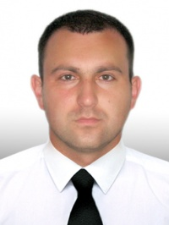

Experience:
Position | From / To | Vessel name | Vessel type | DWT | ME | BHP | Flag | Shipowner | Crewing
3rd Engineer | 24.09.2013-25.03.2014 | SOFIA | Tug Boat | 1500 | SKL | 2000 | UKRAINE | UDASCo | UDASCo
3rd Engineer | 02.02.2013-15.08.2013 | SOFIA | Tug Boat | 1500 | SKL | 2000 | UKRAINE | UDASCo | UDASCo
3rd Engineer | 24.08.2012-10.01.2013 | SOFIA | Tug Boat | 1500 | SKL | 2000 | UKRAINE | UDASCo | UDASCo
Motorman 1st class | 02.02.2012-15.08.2012 | DNEPROPETROVSK | Tug Boat | 1500 | SKL | 2000 | UKRAINE | UDASCo | UDASCo

