Tymoshemko Artem
Position applied for: Deck Cadet  Date of birth: 04.07.1998 (age: 19)  Citizenship: Ukraine  Residence permit in Ukraine: Yes  Country of residence: Ukraine  City of residence: Odessa  Permanent address: Malovskogo 10  Contact Tel. No: +38 (095) 552-88-02  E-Mail: arttim10@gmail.com  Skype: temochka14  U.S. visa: No  E.U. visa: No  Ukrainian biometric international passport: Not specified  Date available from: 30.12.2017  English knowledge: Excellent  Minimum salary: 300 $ per month | 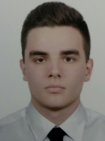

Experience:
Position | From / To | Vessel name | Vessel type | DWT | ME | BHP | Flag | Shipowner | Crewing
Deck Cadet | 26.05.2016-31.08.2016 | SLV - 400 | Pollution Control Vessel | 435000 |  | - |  |  | &mdash;

