Fomenko Sergii Sergiyovuch
Position applied for: Ordinary Seaman  Date of birth: 14.06.1988 (age: 29)  Citizenship: Ukraine  Residence permit in Ukraine: No  Country of residence: Ukraine  City of residence: Tsyurupynsk  Permanent address: Nijniaya str. 40  Contact Tel. No: +38 (050) 958-73-57 / +38 (055) 422-10-55  E-Mail: Sfomenko@gmail.com  U.S. visa: No  E.U. visa: No  Ukrainian biometric international passport: Not specified  Date available from: 22.05.2012  English knowledge: Moderate  Minimum salary: 600 $ per month | 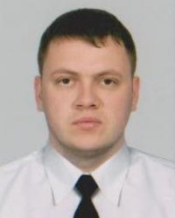

Experience:
Position | From / To | Vessel name | Vessel type | DWT | ME | BHP | Flag | Shipowner | Crewing
Ordinary Seaman | 18.03.2011-20.05.2011 | Alla | Dry Cargo |  |  | - | Ukraine |  | &mdash;

