Tkachenko Sergii
Position applied for: Master  Date of birth: 07.08.1971 (age: 46)  Citizenship: Ukraine  Residence permit in Ukraine: No  Country of residence: Ukraine  City of residence: &mdash;  Contact Tel. No: +38 (050) 600-09-09 / +38 (066) 776-97-97  E-Mail: seredina@inbox.ru  U.S. visa: No  E.U. visa: No  Ukrainian biometric international passport: Not specified  Date available from: 30.09.2013  English knowledge: Excellent  Minimum salary: 14000 $ per month | 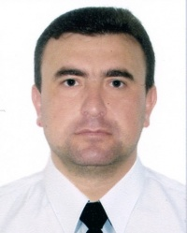

Experience:
Position | From / To | Vessel name | Vessel type | DWT | ME | BHP | Flag | Shipowner | Crewing
Master | 29.09.2013-20.05.2014 | WHITE PURL | LPG Tanker | 12000 | B&W | 9500 | PANAMA |  | AMADEY
Master | 25.05.2013-15.09.2013 | AZERI GAS | Gas Tanker | 7200 | B&W | - | MALTA | PALMALI | &mdash;
Master | 25.08.2012-29.01.2013 | AZERI GAS | Gas Tanker | 7200 | B&W | - | MALTA | PALMALI | &mdash;
Master | 09.01.2012-20.04.2012 | LUKE | Gas Tanker | 4000 | B&W | - | PORTUGAL |  | &mdash;

