Stepanov Sergiy Ivanovich
Position applied for: Chief Officer  Date of birth: 12.12.1987 (age: 29)  Citizenship: Ukraine  Residence permit in Ukraine: Yes  Country of residence: Ukraine  City of residence: Odessa  Contact Tel. No: +38 (063) 825-23-92 / +38 (097) 210-06-32  E-Mail: mniserge@mail.ru  Skype: mniserge  U.S. visa: Yes. Expiration date 05.10.2022  E.U. visa: No  Ukrainian biometric international passport: Not specified  Date available from: 01.12.2017  English knowledge: Good  Minimum salary: 7000 $ per month | 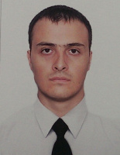

Experience:
Position | From / To | Vessel name | Vessel type | DWT | ME | BHP | Flag | Shipowner | Crewing
Chief Officer | 25.11.2016-14.06.2017 | MSC ELSA 3 | Container Ship | 22994 | SULZER | 18110 | Liberia | MSC | MSC

