Konstantiuk Vitalii Vladimirovich
Position applied for: Electrician  Date of birth: 01.01.1980 (age: 37)  Citizenship: Ukraine  Residence permit in Ukraine: No  Country of residence: Ukraine  City of residence: Rozdilna  Permanent address: 67400 str.Frunze 12  Contact Tel. No: +38 (048) 535-08-65 / +38 (099) 751-44-08  E-Mail: vitaliy80k@rambler.ru  U.S. visa: No  E.U. visa: No  Ukrainian biometric international passport: Not specified  Date available from: 15.08.2013  English knowledge: Moderate  Minimum salary: 1500 $ per month | 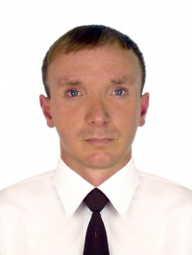

Experience:
Position | From / To | Vessel name | Vessel type | DWT | ME | BHP | Flag | Shipowner | Crewing
Electrician | 05.11.2013-03.02.2014 | ARIZONA | Universal Ship | 878 | Caterpillar | 1250 | Sierra Leone | AdvanFort LTD | G-Marine Limited
Electrician | 05.06.2012-15.11.2012 | Soley 1 | Chemical Tanker | 19992 | MAN | 9457 | Malta | Maritime & Trading LTD | Biznes Consal
Electrician | 08.09.2011-29.04.2012 | m/v MANAS | Dry Cargo | 4060 | SKODA | 1030 | Sierra-Leone | Zifamuto Shipping | Limar Tim

