Tokarskiy Denis Ivanovich
Position applied for: Able Seaman  Date of birth: 28.11.1980 (age: 36)  Citizenship: Ukraine  Residence permit in Ukraine: No  Country of residence: Ukraine  City of residence: Odessa  Contact Tel. No: +38 (048) 252-09-38 / +38 (098) 477-61-60  E-Mail: bersaco@mail.ru  U.S. visa: No  E.U. visa: No  Ukrainian biometric international passport: Not specified  Date available from: 10.10.2013  English knowledge: Poor  Minimum salary: 500 $ per month | 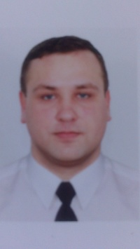

Experience:
Position | From / To | Vessel name | Vessel type | DWT | ME | BHP | Flag | Shipowner | Crewing
Able Seaman | 13.05.2007-03.11.2007 | MARS | Bunkering Vessel | 5000 |  | - | M.I. | LASSI SHIPPING CO.LTD | STATUS
Able Seaman | 08.04.2005-31.03.2007 | MONERON | Bunkering Vessel | 3108 |  | - | UKRAINE | ERBS SHIPPING.LTD | TRANSBUNKER
Able Seaman | 25.06.2004-28.01.2005 | TRANSBUNKER | Tanker Crude | 3330 |  | - | CAMBODIA | ERBS SHIPPING.LTD | TRANSBUNKER
Able Seaman | 10.01.2004-21.05.2004 | PETR ZAVYALOV | Tanker Crude | 3801 |  | - | BELIZE | ERBS SHIPPING.LTD | TRANSBUNKER
Able Seaman | 14.10.2003-09.01.2004 |  | Tanker Crude | 3801 |  | - | BELIZE | ERBS SHIPPING.LTD | TRANSBUNKER
Deck Cadet | 29.08.2003-01.10.2003 | INZHENER ROZHKOV | Bunkering Vessel | 3108 |  | - | UKRAINE | ERBS SHIPPING.LTD | TRANSBUNKER

