Katrenko Vladislav Alexandrovich
Position applied for: Electrical Engineer  Date of birth: 15.03.1954 (age: 63)  Citizenship: Ukraine  Residence permit in Ukraine: No  Country of residence: Ukraine  City of residence: Kherson  Permanent address: blukhera 54/21  Contact Tel. No: +38 (055) 242-56-53 / +38 (067) 551-61-72  E-Mail: VLAD.KATREN@GMAIL.COM  U.S. visa: No  E.U. visa: No  Ukrainian biometric international passport: Not specified  Date available from: 15.01.2013  English knowledge: Good  Minimum salary: 5500 $ per month | 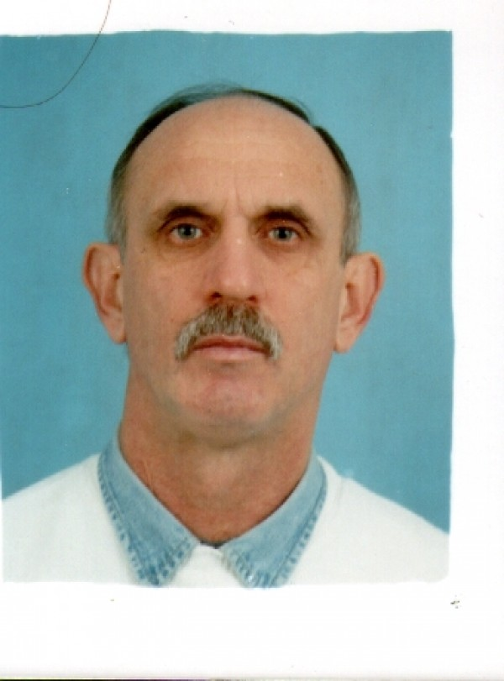

Experience:
Position | From / To | Vessel name | Vessel type | DWT | ME | BHP | Flag | Shipowner | Crewing
 | 29.01.2014-24.05.2014 | Furuholmen | Chemical Tanker | 16500 | MAN | 7045 | Panama | Norbulk UK | Hanza Riga
 | 04.06.2013-30.09.2013 | Furuholmen | Chemical Tanker | 16500 | MAN B&W | - | Panama | Norbulk | Hanza
 | 25.07.2012-26.10.2012 | SEALING | Product Tanker | 32480 | MAN B&W | 11342 | GERMANY | GERMAN TANKER | MARLOW
 | 24.12.2011-15.03.2012 | GLOBAL STAR | Chemical Tanker | 4500 | MAN | 2X1280 | GIBRALTAR | UNIFLEET | NORTHSEATANKERS
 | 29.06.2011-06.10.2011 | CRYSTAL EMERALD | Chemical Tanker | 8143 | SULZER | 5875 | LAXEMBOURG | CRYSTAL POOL | SPECTRUM
 | 19.01.2011-25.04.2011 | SYN MIZAR | LPG Tanker | 4290 | GMT | 4200 | MALTA | SYNERGAS | ITERMARINE
 | 30.07.2010-30.11.2010 | MIMMO IEVOLI | Chemical Tanker | 9905 | WARTSILA | 7180 | ITALY | MARNAVI | INTERMARINE
 | 14.03.2010-30.06.2010 | LIA IEVOLI | Chemical Tanker | 9976 | WARTSILA | 7180 | ITALY | MARNAVI | INTERMARINE
 | 20.06.2009-21.10.2009 | IEVOLI SHINE | Chemical Tanker | 9935 | WARTSILA | 7180 | ITALY | MARNAVI | INTERMARINE
 | 05.02.2009-07.05.2009 | luca ievoli | Chemical Tanker | 5207 | wartsila | 4080 | italy | marnavi | intermarine
 | 18.08.2007-19.12.2008 | luca ievoli | Chemical Tanker | 5207 | wartsila | 4080 | italy | marnavi | intermarine
 | 28.02.2008-26.06.2008 | lia ievoli | Chemical Tanker | 9976 | wartsila | 7179 | italy | marnavi | intermarine
 | 24.02.2007-06.07.2006 | ievoli speed | Chemical Tanker | 7982 | wartsila | 5625 | italy | marnavi | intermarine

