Boldyrev Volodymyr
Position applied for: 2nd Engineer  Date of birth: 24.05.1982 (age: 35)  Citizenship: Ukraine  Residence permit in Ukraine: No  Country of residence: Ukraine  City of residence: Sevastopol  Permanent address: Kosarev str.7  Contact Tel. No: +38 (066) 201-78-50 / +38 (069) 242-70-49  E-Mail: boltikseeman@inbox.ru  U.S. visa: No  E.U. visa: No  Ukrainian biometric international passport: Not specified  Date available from: 26.12.2013  English knowledge: Good  Minimum salary: 6300 $ per month | 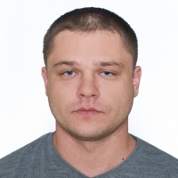

Experience:
Position | From / To | Vessel name | Vessel type | DWT | ME | BHP | Flag | Shipowner | Crewing
2nd Engineer | 13.06.2012-18.02.2013 | Falshoeft | Heavy Lift Vessel | 8861 | Wartsila 8L46B | 7800 | Isle of Man | Brize. Hamburg. Germany | Sea Factor

