Kalchenko Oleg
Position applied for: 3rd Officer  Date of birth: 20.09.1967 (age: 50)  Citizenship: Ukraine  Residence permit in Ukraine: No  Country of residence: Ukraine  City of residence: &mdash;  Permanent address: pokrisheva8/155  Contact Tel. No: +38 (055) 231-99-90 / +38 (095) 864-82-79  E-Mail: kalchenko.1967@mail.ru  U.S. visa: No  E.U. visa: No  Ukrainian biometric international passport: Not specified  Date available from: 14.10.2013  English knowledge: Moderate  Minimum salary: 2500 $ per month | 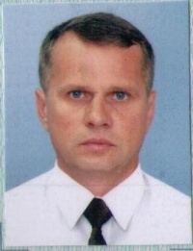

Experience:
Position | From / To | Vessel name | Vessel type | DWT | ME | BHP | Flag | Shipowner | Crewing
3rd Officer | 04.12.2012-25.06.2013 | Agata M | Heavy Lift Vessel | 8000 |  | - | Panama | Agata shipping LTD | Poseidon

