Kyrylenko Roman
Position applied for: 4th Engineer  Date of birth: 02.03.1982 (age: 35)  Citizenship: Ukraine  Residence permit in Ukraine: No  Country of residence: Ukraine  City of residence: Sevastopol  Contact Tel. No: +38 (069) 241-05-03 / +38 (095) 578-39-91  E-Mail: tom226@mail.ru  U.S. visa: No  E.U. visa: No  Ukrainian biometric international passport: Not specified  Date available from: 01.04.2013  English knowledge: Good  Minimum salary: 2000 $ per month | 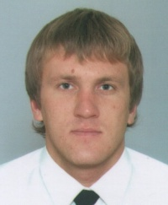

Experience:
Position | From / To | Vessel name | Vessel type | DWT | ME | BHP | Flag | Shipowner | Crewing
4th Engineer | 23.07.2003-23.01.2014 | MSC Albany | Container Ship | 94017 | MAN B W | 47430 | Liberia | XT Shipping | Vita maritime
4th Engineer | 29.01.2012-16.05.2012 | Car Star | Ro-Ro | 50000 | Mitsubishi | 10000 | Liberia | Ofer broth. inc | Vita Maritime
4th Engineer | 22.02.2011-03.06.2011 | Geroi Sevastopolya | Passenger Ship | 1987 | Zulcer | 4000 | Ukeaine | Firma Sudostroenie | &mdash;
Motorman 2nd class | 18.08.2009-08.02.2011 | Geroi Sevastopolya | Passenger Ship | 1987 | Zulcer | 4000 | UKR | Firma Sudostroenie | &mdash;

