Дмитренко Владимир Алексеевич
Position applied for: Electrical Engineer  Date of birth: 31.08.1954 (age: 63)  Citizenship: Ukraine  Residence permit in Ukraine: No  Country of residence: Ukraine  City of residence: Sevastopol  Permanent address: Косарева 27-131  Contact Tel. No: +38 (050) 194-89-11  E-Mail: vladimir-dm@km.ru  U.S. visa: No  E.U. visa: No  Ukrainian biometric international passport: Not specified  Date available from: 23.05.2009  English knowledge: Moderate  Minimum salary: 4000 $ per month | 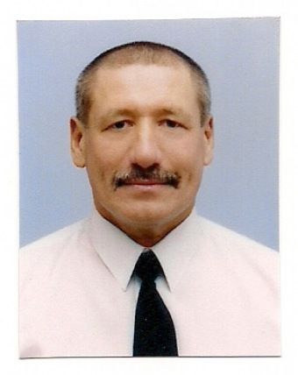

Experience:
Position | From / To | Vessel name | Vessel type | DWT | ME | BHP | Flag | Shipowner | Crewing
 | 06.06.2008-06.04.2009 | MV"PETANI" | Bulk Carrier | 75228 |  | 12226 | Malta | Cardiff Marine | Sea Way
 | 19.06.2007-23.04.2008 | MV"DANAE" | Bulk Carrier | 75106 |  | 15190 | Greece | Diana Shipping Inc. | Sea Way
 | 14.11.2006-29.04.2007 | MV"Cape Eagle" | Bulk Carrier | 161475 |  | 19398 | UK | Zodiac Maritime | Transcontract
 | 15.03.2006-27.09.2006 | MV"DUHALLOW" | Bulk Carrier | 122774 |  | 13978 | Bermuda | Zodiac Maritime | Transcontract
 | 11.02.2005-23.11.2005 | MV"RUTLAND" | Bulk Carrier | 170013 |  | 22018 | Bermuda | Zodiac Maritime | Transcontract

