Безручко Олег Александрович
Position applied for: 2nd Officer  Date of birth: 29.03.1974 (age: 43)  Citizenship: Ukraine  Residence permit in Ukraine: No  Country of residence: Ukraine  City of residence: Mariupol  Contact Tel. No: +38 (096) 308-71-54  E-Mail: ZOO777@MAIL.RU  U.S. visa: No  E.U. visa: No  Ukrainian biometric international passport: Not specified  Date available from: 10.08.2009  English knowledge: Moderate  Minimum salary: 3200 $ per month | 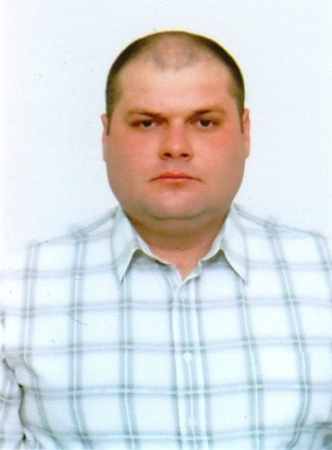

Experience:
Position | From / To | Vessel name | Vessel type | DWT | ME | BHP | Flag | Shipowner | Crewing
2nd Officer | 12.04.2008-16.10.2008 | SAMBOR | Bulk Carrier | 11000 |  | - | BELIZE | SAMBOR SHIPPING & TRADING CO. | ISG
2nd Officer | 23.10.2004-10.09.2005 | BELMOPAN | Bulk Carrier | 14000 | 7400 | - | BELIZE | BELMOPAN SHIPPING & TRADING CO. | ISG
2nd Officer | 14.08.2003-31.03.2004 | BELMOPAN | Bulk Carrier | 14000 | 7400л.с | - | BELIZE | BELMOPAN SHIPPING & TRADING CO. | ISG
2nd Officer | 22.08.2002-30.03.2003 | BANAM | Bulk Carrier | 11000 |  | - | CAMBODJIA | BANAM SHIPPING & TRADING CO. | ISG

