John Tuzelo
Position applied for: Master  Date of birth: 28.02.1931 (age: 86)  Citizenship: Uganda  Residence permit in Ukraine: No  Country of residence: Ukraine  City of residence: Hlobyne  Permanent address: Gemora 78 str ap19  Contact Tel. No: +38 (095) 901-81-31  E-Mail: lucki.roma4@gmail.com  U.S. visa: No  E.U. visa: No  Ukrainian biometric international passport: Not specified  Date available from: 09.12.2013  English knowledge: Excellent  Minimum salary: 15000 $ per month | 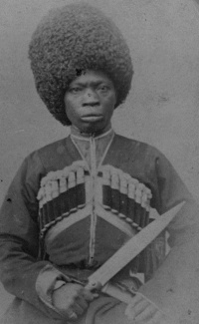

Experience:
Position | From / To | Vessel name | Vessel type | DWT | ME | BHP | Flag | Shipowner | Crewing
Master | 00.00.0000-00.00.0000 |  | Ferry |  |  | - |  |  | &mdash;
Master | 00.00.0000-00.00.0000 |  |  |  |  | - |  |  | &mdash;
Master | 00.00.0000-00.00.0000 |  |  |  |  | - |  |  | &mdash;
Master | 00.00.0000-00.00.0000 |  |  |  |  | - |  |  | &mdash;

