Давыдов Виталий
Position applied for: 3rd Engineer  Date of birth: 21.04.2985 (age: 967)  Residence permit in Ukraine: No  Country of residence: Ukraine  City of residence: Chornomorsk  Contact Tel. No: +38 (063) 205-18-58  E-Mail: vitaliydavydov@mail.ru  U.S. visa: No  E.U. visa: No  Ukrainian biometric international passport: Not specified  Date available from: 12.05.2010  English knowledge: Good  Minimum salary: 4500 $ per month | 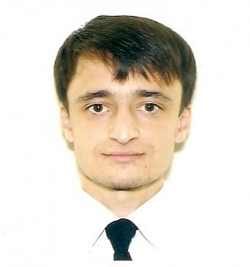

Experience:
Position | From / To | Vessel name | Vessel type | DWT | ME | BHP | Flag | Shipowner | Crewing
3rd Engineer | 00.00.0000-00.00.0000 | Zim Texas | Container Ship | 34500 | Sulzer | 24440 | Liberia | Reederei F. Laeisz | &mdash;
3rd Engineer | 00.00.0000-00.00.0000 | Cific | Container Ship | 34500 | Sulzer | 24440 | Liberia | Reederei F. Laeisz | &mdash;
3rd Engineer | 00.00.0000-00.00.0000 | Green Point | Tanker Product | 29500 | MAN B&W | 11300 | Liberia | CST | &mdash;
3rd Engineer | 00.00.0000-00.00.0000 | Chemtrans Lyra | Tanker Product |  |  | - | Liberia | CST | &mdash;

