Sokolenko Serhiy
Position applied for: 3rd Engineer  Date of birth: 07.07.1989 (age: 28)  Citizenship: Ukraine  Residence permit in Ukraine: Yes  Country of residence: Ukraine  City of residence: Kherson  Permanent address: Kotlyarevskogo, str, b78, app68  Contact Tel. No: +38 (095) 184-96-31  E-Mail: seregasokol2@mail.ru  Skype: seregasokol27  U.S. visa: No  E.U. visa: No  Ukrainian biometric international passport: Not specified  Date available from: 19.03.2017  English knowledge: Moderate  Minimum salary: 1500 $ per month | 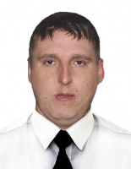

Experience:
Position | From / To | Vessel name | Vessel type | DWT | ME | BHP | Flag | Shipowner | Crewing
AB-Motorman | 18.09.2008-06.03.2009 | Roza-H | General Cargo | 2592 | shkoda 27.5a2l | - |  |  | &mdash;

