Yevdoscchenko Sergiy
Position applied for: Chief Officer  Date of birth: 17.09.1969 (age: 48)  Citizenship: Ukraine  Residence permit in Ukraine: No  Country of residence: Ukraine  City of residence: Bilhorod-Dnistrovskyy  Contact Tel. No: +38 (048) 492-48-70 / +38 (050) 392-27-51  E-Mail: chc1064@bigmir.net  U.S. visa: No  E.U. visa: No  Ukrainian biometric international passport: Not specified  Date available from: 01.01.2012  English knowledge: Moderate  Minimum salary: 6000 $ per month | 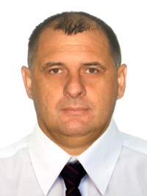

Experience:
Position | From / To | Vessel name | Vessel type | DWT | ME | BHP | Flag | Shipowner | Crewing
Chief Officer | 25.06.2011-12.12.2011 | Mauritanker | Product Tanker | 9025 | MAN | 4400 | Panama | Mondial shipping | Universal service

Documents and further information:
Имею опыт работы на танкерах в должности старпома и на бункеровщиках в должности капитана. Документы до 2016 года. Диплом КДП без ограничений.

