Radionov Vadim Nikolaevich
Position applied for: Gaz Engineer  Date of birth: 20.03.1964 (age: 53)  Citizenship: Ukraine  Residence permit in Ukraine: No  Country of residence: Ukraine  City of residence: Sevastopol  Permanent address: Kolobova 17, flat 49  Contact Tel. No: +38 (050) 190-78-95 / +38 (069) 243-18-16  E-Mail: Radionov64@mail.ru  U.S. visa: No  E.U. visa: No  Ukrainian biometric international passport: Not specified  Date available from: 15.11.2013  English knowledge: Good  Minimum salary: 5500 $ per month | 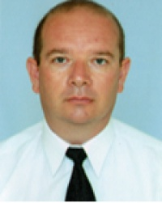

Documents and further information:
Seamans passportAB309545 14122005Sevastopol14062015Foreign passport EE476195 05092008Sevastopol05092018Cert of Competency 00073200707 15092007Nikolaev-Endorsement 00073200707 1509200Nikolaev 23082012Panama passport 306330 04012007Londres 04012012MEDICAL FIRST AID ON BOARD SHIP MEDICAL CARE 01855C23082007Sevastopol23082012PROFICIENCY IN SURVIVAL CRAFT 04456C23082007Sevastopol23082012ADVANCED FIRE FIGHTING 02971C23082007Sevastopol23082012OIL TANKERS SPECIALIZED TRAINING 01778SV6092007Sevastopol06092012GAS TANKERS SPECIALIZED TRAINING 0025SV6092007Sevastopol06092012YELLOW FEVER VACCINATION 055UFA055Z02072007Busan0207201

