Yershov Igor
Position applied for: Chief Officer  Date of birth: 13.04.1984 (age: 33)  Citizenship: Ukraine  Residence permit in Ukraine: No  Country of residence: Ukraine  City of residence: Izmail  Contact Tel. No: +38 (096) 926-86-04  E-Mail: igoryershov@mail.ru  U.S. visa: No  E.U. visa: No  Ukrainian biometric international passport: Not specified  Date available from: 05.03.2014  English knowledge: Moderate  Minimum salary: 5000 $ per month | 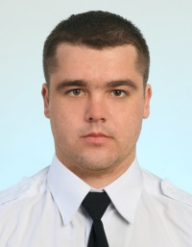

Experience:
Position | From / To | Vessel name | Vessel type | DWT | ME | BHP | Flag | Shipowner | Crewing
Chief Officer | 03.06.2013-22.11.2013 | AMBER TRADER | Multi-Purpose Vessel |  |  | - |  |  | &mdash;
Chief Officer | 11.12.2012-01.04.2013 | EMI LEADER | Multi-Purpose Vessel |  |  | - |  |  | &mdash;
Chief Officer | 05.11.2011-05.06.2012 | SIDERFLY | General Cargo |  |  | - |  |  | &mdash;
2nd Officer | 17.02.2011-28.06.2011 | SIDERFLY | General Cargo |  |  | - |  |  | &mdash;
2nd Officer | 19.09.2009-01.03.2010 | SUN LEADER | General Cargo |  |  | - |  |  | &mdash;
3rd Officer | 10.04.2008-13.11.2008 | KILIYA | General Cargo |  |  | - |  | UDP | &mdash;
3rd Officer | 17.06.2007-29.12.2007 | RAKHOV | General Cargo |  |  | - | Ukraine | UDP | &mdash;

