Варюхин Кирилл Вячеславович
Position applied for: 3rd Officer  Date of birth: 29.04.1983 (age: 34)  Citizenship: Ukraine  Residence permit in Ukraine: No  Country of residence: Ukraine  City of residence: Sevastopol  Permanent address: ул. Шевченко д. 47 кв. 13  Contact Tel. No: +38 (050) 878-58-05  E-Mail: KKirillVV@gmail.com  U.S. visa: No  E.U. visa: No  Ukrainian biometric international passport: Not specified  Date available from: 14.05.2009  English knowledge: Good  Minimum salary: 2000 $ per month | 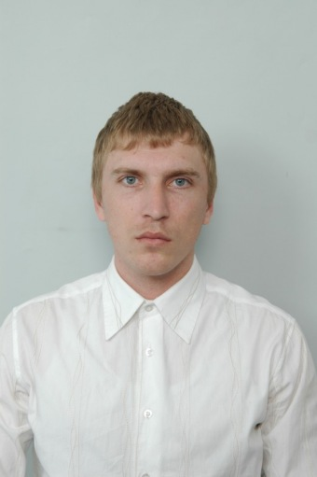

Experience:
Position | From / To | Vessel name | Vessel type | DWT | ME | BHP | Flag | Shipowner | Crewing
Ordinary Seaman | 20.11.2007-23.08.2008 |  | Container Ship | 66280 |  | - | Liberia | Peter Dohle | ATT Bermudas
Ordinary Seaman | 04.01.2007-07.05.2007 | CMA CGM Virginia | Container Ship | 40770 |  | - | Liberia | Zodiac Maritime Agencies | &mdash;
Able Seaman | 08.04.2005-13.11.2005 | Prex | Bulk Carrier | 31643 |  | - | Malta | Tornado shipping | СИ Фактор

