Stupak Aleksandr
Position applied for: Deck Cadet  Date of birth: 02.06.1989 (age: 28)  Citizenship: Ukraine  Residence permit in Ukraine: No  Country of residence: Ukraine  City of residence: Sevastopol  Permanent address: app 4,Blukhera str, 9  Contact Tel. No: +38 (065) 232-33-90 / +38 (066) 770-45-49  E-Mail: aleksandr_stupak.89@mail.ru  U.S. visa: No  E.U. visa: No  Ukrainian biometric international passport: Not specified  Date available from: 10.09.2012  English knowledge: Good  Minimum salary: 300 $ per month | 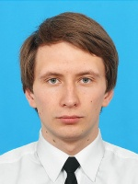

Experience:
Position | From / To | Vessel name | Vessel type | DWT | ME | BHP | Flag | Shipowner | Crewing
Deck Cadet | 03.05.2012-09.07.2012 | Azov | Refrigerator | 2399 |  | - |  | LTD "Linart" | &mdash;

