Skornytsky Dmitriy
Position applied for: Motorman 1st class  Date of birth: 06.01.1985 (age: 32)  Citizenship: Ukraine  Residence permit in Ukraine: Yes  Country of residence: Ukraine  City of residence: Kherson  Permanent address: 103 ostrovskogo str  Contact Tel. No: +38 (055) 229-98-90 / +38 (066) 673-12-88  E-Mail: skornytsky.d@mail.ru  Skype: Skornytsky  U.S. visa: No  E.U. visa: No  Ukrainian biometric international passport: Not specified  Date available from: 15.01.2017  English knowledge: Good  Minimum salary: 1500 $ per month | 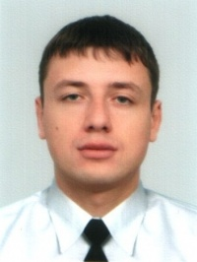

Documents and further information:
seamen`s identification card AB 451474
Travel passport EH 581474
Qualified motorman certificate 00389/2010/11
Endorsment 00389/2010/11
Basic safety training and instruction 17333/2010/25/01
Proficiency in survival craft and rescue boats 17334/2010/25/02
Tanker familization course 17335/2010/25/10

