Shchierbyna Yevhen Borysovych
Position applied for: Ordinary Seaman  Date of birth: 05.09.1990 (age: 27)  Citizenship: Ukraine  Residence permit in Ukraine: No  Country of residence: Ukraine  City of residence: Bilhorod-Dnistrovskyy  Permanent address: Odessa region,Belgorod-Dnystrovskyi,st.-t Pobeda 3A  Contact Tel. No: +38 (048) 493-84-75 / +38 (067) 196-35-94  E-Mail: bshchierbina@mail.ru  Skype: jonson-baby1  U.S. visa: No  E.U. visa: No  Ukrainian biometric international passport: Not specified  Date available from: 05.01.2017  English knowledge: Moderate  Minimum salary: 800 $ per month | 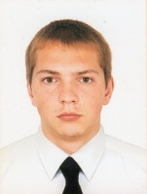

Experience:
Position | From / To | Vessel name | Vessel type | DWT | ME | BHP | Flag | Shipowner | Crewing
Ordinary Seaman | 18.03.2013-20.05.2013 | Diorit | Scientific Vessel | 282 | 970 | 1318,83 | Ukraine | GRGP | Black Sea

