Kondratiuk Mykola
Position applied for: Assistant Waiter  Date of birth: 11.10.1984 (age: 33)  Citizenship: Ukraine  Residence permit in Ukraine: Yes  Country of residence: Ukraine  City of residence: Uman  Permanent address: 98 Petropavlivska str.  Contact Tel. No: +38 (068) 586-39-73  E-Mail: miko.kondratiuk@meta.ua  Skype: mykola.kondratiuk(OZIRIS)  U.S. visa: No  E.U. visa: No  Ukrainian biometric international passport: Not specified  Date available from: 01.11.2017  English knowledge: Excellent  Minimum salary: 1200 $ per month | 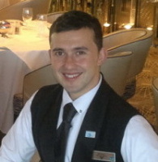

Experience:
Position | From / To | Vessel name | Vessel type | DWT | ME | BHP | Flag | Shipowner | Crewing
Assistant Waiter | 05.05.2016-15.11.2016 | MSC Opera | Cruise Ship |  |  | - |  | MSC Cruises | &mdash;
Assistant Waiter | 12.07.2014-20.02.2015 | Celebrity Solstice | Cruise Ship |  |  | - |  | Celebrity Cruises | &mdash;

