Овчаренко Владимир Владимирович
Position applied for: Chief Engineer  Date of birth: 30.09.1961 (age: 56)  Citizenship: Russia  Residence permit in Ukraine: No  Country of residence: Ukraine  City of residence: Kerch  Contact Tel. No: +38 (050) 428-49-17  E-Mail: ovcharenko.vv@mail.ru  U.S. visa: No  E.U. visa: No  Ukrainian biometric international passport: Not specified  Date available from: 15.09.2009  English knowledge: Good  Minimum salary: 12000 $ per month | 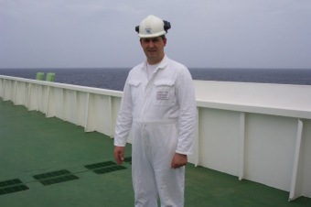

Experience:
Position | From / To | Vessel name | Vessel type | DWT | ME | BHP | Flag | Shipowner | Crewing
Chief Engineer | 31.10.2008-09.04.2009 | FRONT DUKE | INV/VLCC/ULCC | 287 000 TОN |  | 22450 BHP | Singapore | Front Line | V.Ships
Chief Engineer | 13.12.2007-02.06.2008 | FRONT DUKE | INV/VLCC/ULCC | 287 000 ТОN |  | 22450 BHP | Singapore | Front Line | V.Ships
Chief Engineer | 08.09.2006-11.12.2006 | FRON DUKET | INV/VLCC/ULCC | 287 000 ТОN |  | 22450 BHP | Singapore | Front Line | V.Ships
Chief Engineer | 29.09.2005-21.04.2006 | FRONT DUKE | INV/VLCC/ULCC | 287 000 TON |  | 22450 BHP | Singapore | Front Line | V.Ships
Chief Engineer | 07.04.2007-10.08.0007 | FRONT DUKE | INV/VLCC/ULCC | 287 000 ТОN |  | 22450 BHP | Singapore | Front Line | V.Ships

