Nedoviziy Vadym
Position applied for: Electrician  Additional position applied for: Turner  Date of birth: 29.10.1967 (age: 50)  Citizenship: Ukraine  Residence permit in Ukraine: Yes  Country of residence: Ukraine  City of residence: Kherson  Contact Tel. No: +38 (050) 594-24-32  E-Mail: nedovizijvadim@gmail.com  Skype: +380505942432  U.S. visa: No  E.U. visa: No  Ukrainian biometric international passport: Not specified  Date available from: 06.09.2017  English knowledge: Poor  Minimum salary: 1200 $ per month | 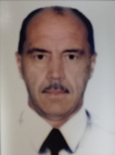

Experience:
Position | From / To | Vessel name | Vessel type | DWT | ME | BHP | Flag | Shipowner | Crewing
Electrician | 19.12.2016-12.06.2017 | Alyaska | General Cargo | 1200 | SKL | 887kw | Belize | Holdingson LTD | Elena

