Bolotniy Dmytro Viktorovich
Position applied for: 2nd Officer  Date of birth: 16.12.1983 (age: 33)  Citizenship: Ukraine  Residence permit in Ukraine: No  Country of residence: Ukraine  City of residence: Sevastopol  Permanent address: st.Menginskogo18/211  Contact Tel. No: +38 (055) 497-19-71 / +38 (095) 448-28-46  E-Mail: bolotnii_dmitrii@mail.ru  U.S. visa: No  E.U. visa: No  Ukrainian biometric international passport: Not specified  Date available from: 04.12.2013  English knowledge: Good  Minimum salary: 1500 $ per month | 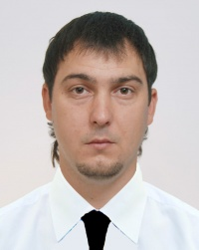

Experience:
Position | From / To | Vessel name | Vessel type | DWT | ME | BHP | Flag | Shipowner | Crewing
3rd Officer | 29.07.2010-29.01.2011 | Vasiliy Tatishev | Dry Cargo | 5009 |  | - | Comoros | Kama Eleven Shipping Compani Ltd | &mdash;
3rd Officer | 19.06.2008-25.10.2008 | Sea Arrow | Dry Cargo | 1650 |  | - | Sierra Leone | Multimedia Marine Group Corp. | &mdash;

