Popkov Ivan
Position applied for: Chief Officer  Date of birth: 03.03.1968 (age: 49)  Citizenship: Ukraine  Residence permit in Ukraine: Yes  Country of residence: Ukraine  City of residence: Kherson  Contact Tel. No: +38 (050) 547-43-20 / +38 (055) 242-24-41  E-Mail: popkov.ivan@gmail.com  Skype: popkov.ivan  U.S. visa: No  E.U. visa: No  Ukrainian biometric international passport: Not specified  Date available from: 15.11.2017  English knowledge: Moderate  Minimum salary: 4500 $ per month | 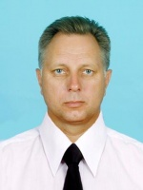

Experience:
Position | From / To | Vessel name | Vessel type | DWT | ME | BHP | Flag | Shipowner | Crewing
Electric Cadet | 10.07.2016-16.01.2017 | Ocean Energy | Multi-Purpose Vessel | 7331 t | MAN B&W | 7724 | LIBERIA | BALTIC TRANS-PORT | UMA

