Nadich Sergii Vyacheslavovich
Position applied for: Ordinary Seaman  Date of birth: 10.01.2014 (age: 3)  Citizenship: Ukraine  Residence permit in Ukraine: No  Country of residence: Ukraine  City of residence: Kerch  Permanent address: Blychera 15-64  Contact Tel. No: +38 (050) 936-09-62 / +38 (065) 617-41-31  E-Mail: sergeynadich@mail.ru  U.S. visa: No  E.U. visa: No  Ukrainian biometric international passport: Not specified  Date available from: 15.02.2014  English knowledge: Moderate  Minimum salary: 1000 $ per month | 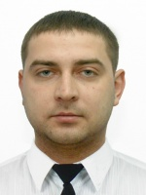

Experience:
Position | From / To | Vessel name | Vessel type | DWT | ME | BHP | Flag | Shipowner | Crewing
Ordinary Seaman | 17.04.2012-03.02.2013 | m/v Olga | Dry Cargo | 1855 | 6vds 26/20 | 2 440 |  | Kaspiys 2012 | &mdash;

