Serdiuk Oleksandr Oleksandrovich
Position applied for: Cook  Date of birth: 28.02.1983 (age: 34)  Citizenship: Ukraine  Residence permit in Ukraine: No  Country of residence: Ukraine  City of residence: Odessa  Permanent address: Dnepropetrovskaya str.108  Contact Tel. No: +38 (048) 254-08-09 / +38 (093) 760-39-76  E-Mail: ser-duk83@ukr.net  U.S. visa: No  E.U. visa: No  Ukrainian biometric international passport: Not specified  Date available from: 10.09.2013  English knowledge: Moderate  Minimum salary: 2000 $ per month | 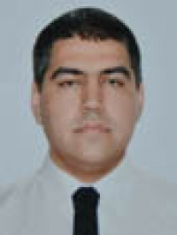

Experience:
Position | From / To | Vessel name | Vessel type | DWT | ME | BHP | Flag | Shipowner | Crewing
Cook | 07.12.2012-14.06.2013 |  | Oil Product Tanker | 73948 |  | - | liberia |  | &mdash;
Mess Boy | 04.12.2011-04.06.2012 |  | Oil Product Tanker | 37759 |  | - | liberia |  | &mdash;

