Korobka Artem Sergeevich
Position applied for: Ordinary Seaman  Date of birth: 13.09.1986 (age: 31)  Citizenship: Ukraine  Residence permit in Ukraine: No  Country of residence: Ukraine  City of residence: Sevastopol  Permanent address: B.Mikhaylova1,kv.44  Contact Tel. No: +38 (066) 273-91-27  E-Mail: as_rylevoj@mail.ru  U.S. visa: No  E.U. visa: No  Ukrainian biometric international passport: Not specified  Date available from: 10.12.2013  English knowledge: Moderate  Minimum salary: 1000 $ per month | 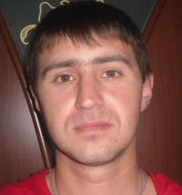

Experience:
Position | From / To | Vessel name | Vessel type | DWT | ME | BHP | Flag | Shipowner | Crewing
Able Seaman | 19.12.2006-20.12.2012 | Darnitsa | Multi-Purpose Vessel | military ship | M 401 B | military ship | Ukraine | military part 2382 | military part 2382

Documents and further information:
In the sea went on military ships in the position of a sailor-steering shared guard is 7 years. In 2012,I graduated from Sevastopol Academy named P.S.Nakhimova and received a degree in Navigator.

